Newstead Girls’ College – Negombo
Applying for the GCE Advanced Level (2020-2022)
(For Internal Applicants)

Instructions for the applicants
- Due to the current situation of Covid-19 in Sri Lanka the GCE Advanced Level Applications for the academic year 2020 - 2022 will be taken via email.
- Please forward your application form which is prepared as per the sample provided to ngcnegombo.app@gmail.com, before 30.05.2020.
- Enter the subject line of the email as INTERNAL if you are an internal applicant and EXTERNAL if you are an external applicant.
- If you are an external school applicant you should bring the completed application form, certified by the school principal when attending the interview.
- All the information given in the application should be completed and the incomplete applications will be rejected.

Basic guidelines to select the stream and the subjects for GCE (Advanced Level)
- The Bio Science, Physical Science (Maths) and Commerce streams can be studied either in Sinhala or English Medium. The Art stream can be only studied in Sinhala Medium.
- In the Commerce stream; the subject, ICT (English Medium) can be selected instead of the subject, Economics.
- In the Physical Science (Maths) stream; the subject, ICT (English Medium) can be selected instead of the subject, Chemistry.
- In the Bio Science stream, the subject, Agriculture (Sinhala Medium) can be selected instead of the subject, Physics.

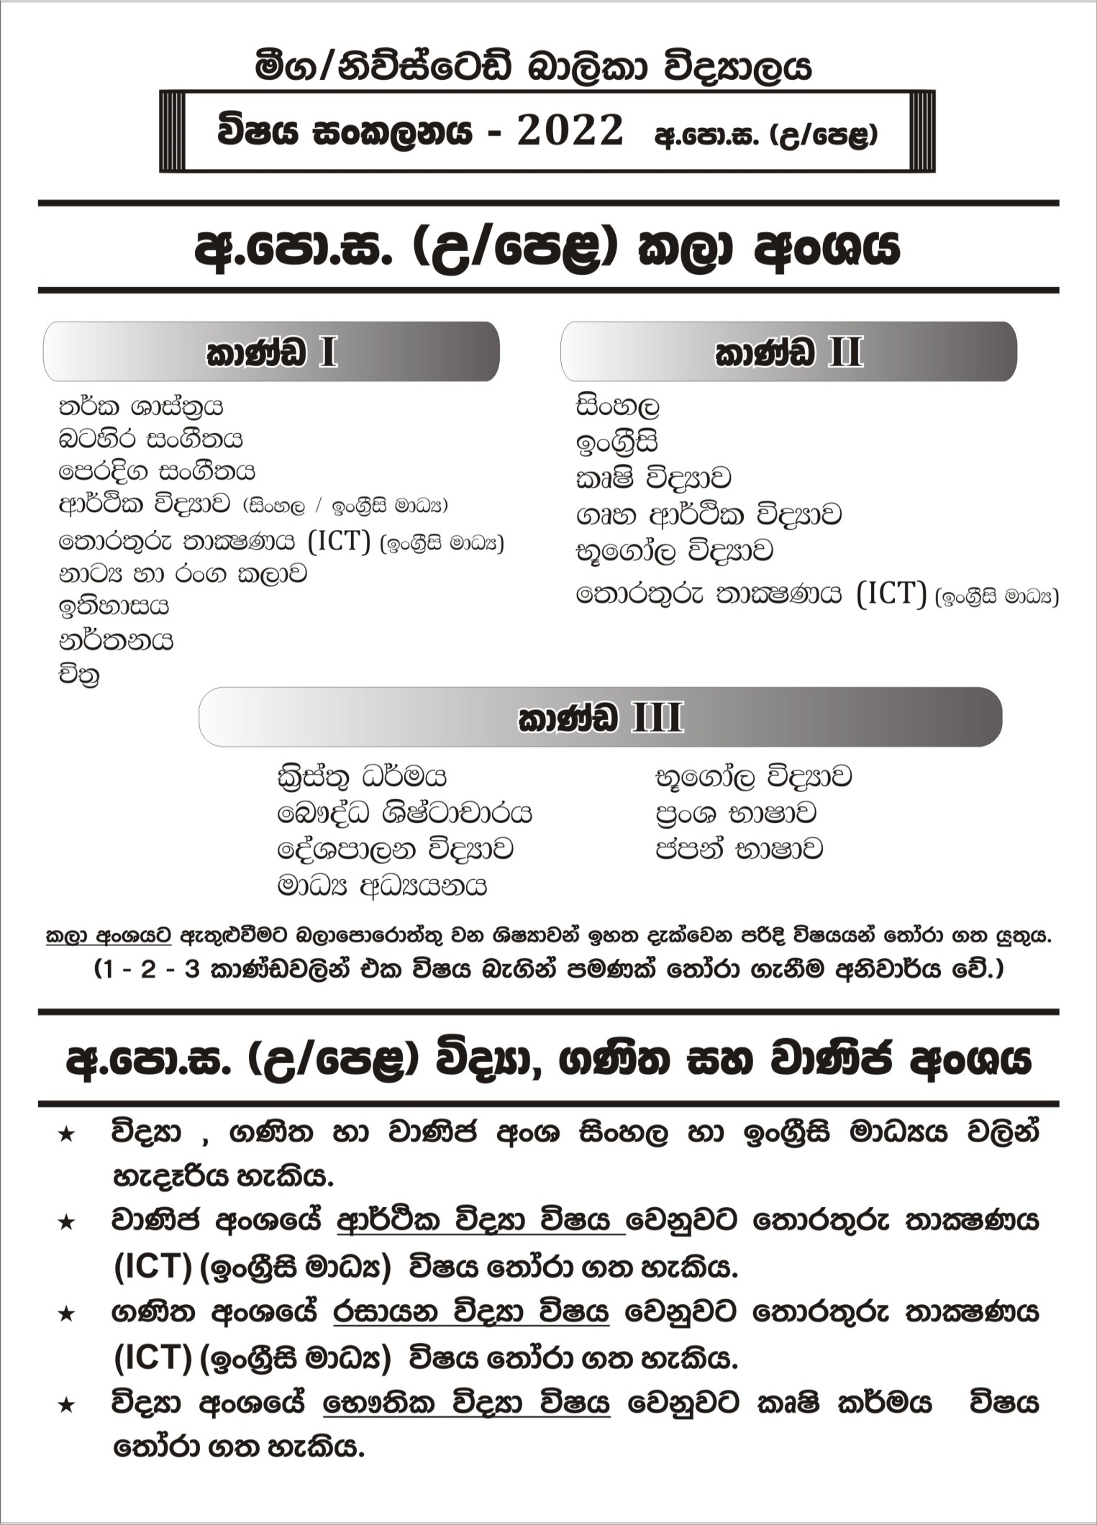
Newstead Girls’ College – Negombo
The Application form for the admission of GCE Advanced Level (2020-2022)
(For Internal Applicants)

Stream
Medium

- Full name of the student :
- The name with initials :
- Date of birth :
- Permanent address :

- The name of father/ mother/ guardian :
- Contact number mobile : land phone :
e-mail address :

- The class studied in grade 11 :
The name of the class teacher in grade 11:

- School admission number :

- GCE (Ordinary Level) results:

First Attempt |  |  | Second Attempt
Index No : |  |  | Index No :
 | Subject | Result | Subject | Result
1
2
3
4
5
6
7
8
9
10

- The subjects intended to follow in GCE Advanced Level
………………….. (ii)………..………….. (iii)……………………

